8 Puzzle program
AIM: To write a python program for 8-Puzzle Problem.

OBJECTIVES:
- To solve the 8-puzzle problem by moving tiles from an initial state to the goal state.
- To arrange the numbers 1 to 8 in the correct order using the blank space.
- To find the minimum number of moves required to reach the goal state.

ALGORITHM:
- Start with the given initial puzzle configuration.
- Define the goal state as 1234567890.
- Add the initial state to the queue.
- Remove a state from the queue and check whether it matches the goal state.
- Generate possible moves by moving the blank space (up, down, left, right).
- Add new states to the queue if they are not already visited.
- Repeat until the goal state is reached.
- Display the sequence of moves and total number of moves.

SYSTEM ARCHITECTURE:
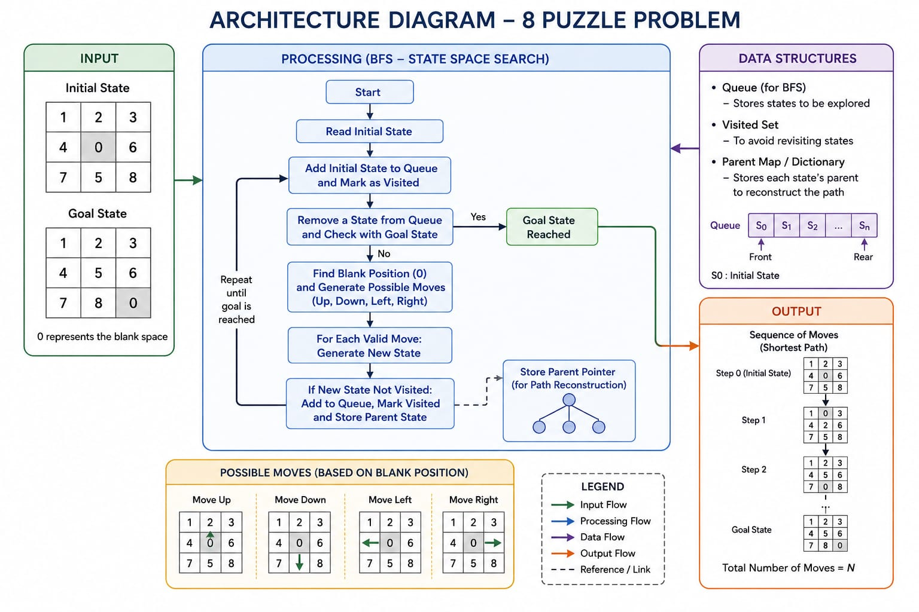

PROGRAM:
from collections import deque

goal = "123456780"

print("Enter the puzzle (0 for blank):")
start = ""
for i in range(3):
start += "".join(input().split())

q = deque([(start, "", 0)])
visited = {start}

moves = [(-1,0,'U'), (1,0,'D'), (0,-1,'L'), (0,1,'R')]

while q:
state, path, count = q.popleft()

if state == goal:
print("Solved!")
print("Moves:", path)
print("Total Moves =", count)
break

z = state.index('0')
r, c = divmod(z, 3)

for dr, dc, m in moves:
nr, nc = r + dr, c + dc
if 0 <= nr < 3 and 0 <= nc < 3:
nz = nr * 3 + nc
s = list(state)
s[z], s[nz] = s[nz], s[z]
new = "".join(s)
if new not in visited:
visited.add(new)
q.append((new, path + m, count + 1))

Output:
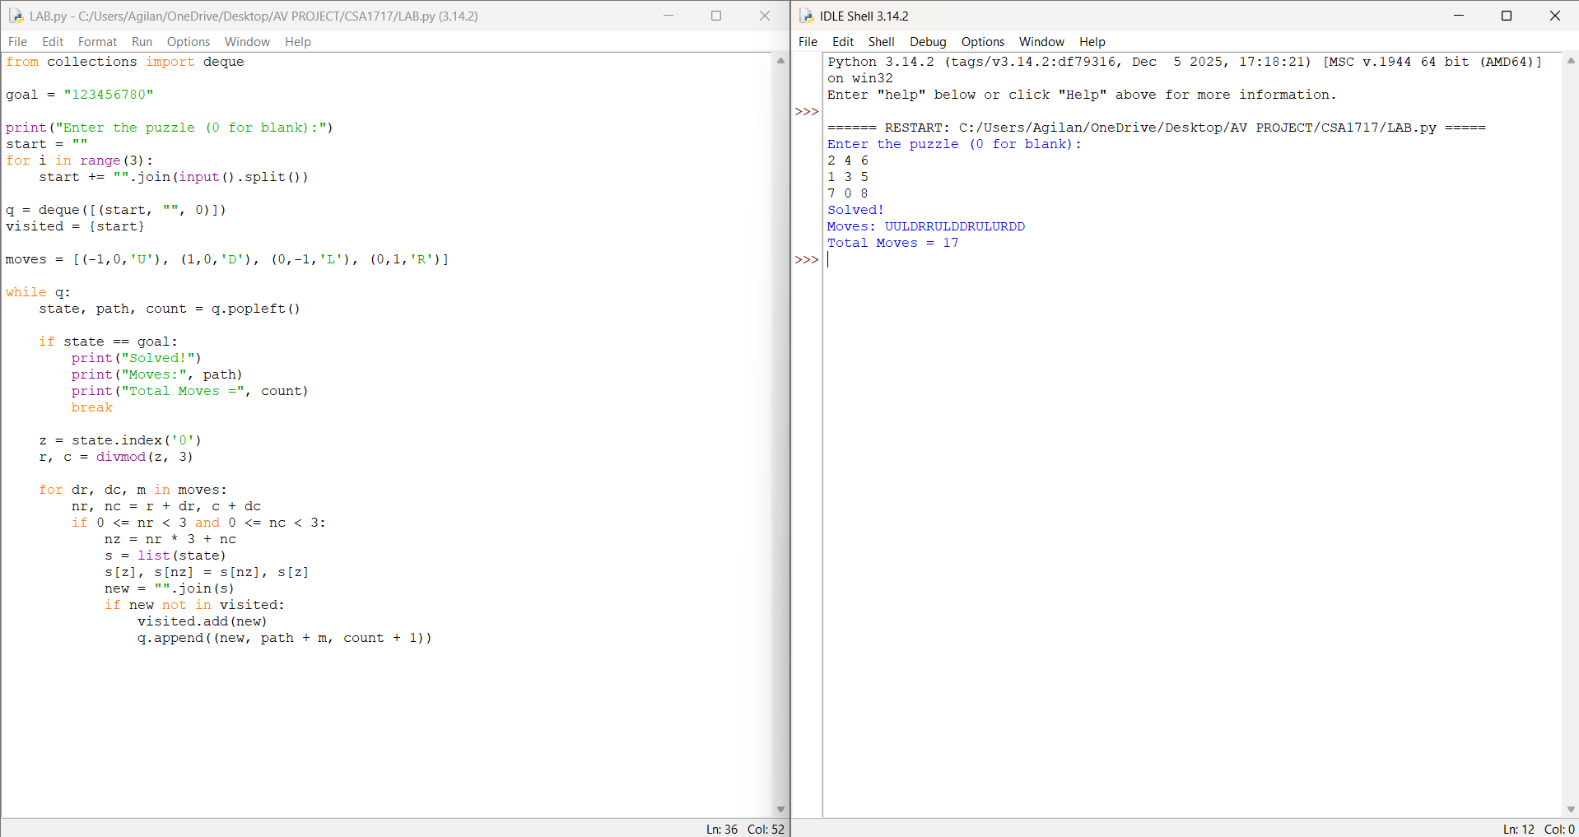

RESULT:Thus the 8-Puzzle problem is implemented successfully using pthon language.

